# **Jmeter Distributed (Remote) Testing: Master Slave Configuration**

## **What is Distributed Testing?**

Distributed[Testing](https://www.guru99.com/software-testing.html)is a kind of testing which use multiple systems to perform [Stress Testing](https://www.guru99.com/stress-testing-tutorial.html). Distributed testing is applied for testing websites and server applications when they are working with multiple clients simultaneously.

Distributed testing uses client-server model as the figure below:

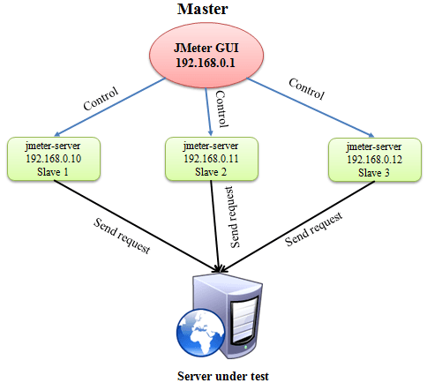

* **Master**: the system running JMeter GUI, control each slave.
* **Slave**: the system running JMeter-server, receive a command from the master and send a request to a server under test.
* **Target**: the web server under test, get a request from slaves.

00:16

35:

## **Remote Test Example**

**Precondition:**

* The firewalls on the systems are turned off. In some cases, the firewall may still be blocking the traffic. You should disable the Window firewall or[Linux](https://www.guru99.com/unix-linux-tutorial.html)firewall.
* All the machines should be on the same subnet. If machines are not on the same subnet, maybe they will not recognize each other in the network.
* Use the same version of JMeter to avoid unanticipated errors/issues.

Here is the **roadmap** for this testing:

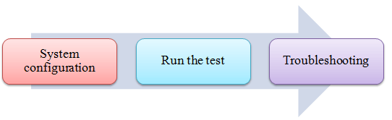

## **Step 1) System configuration**

Setup **slave** systems, go to jmeter/bin directory and execute file “jmeter-server.bat”.

Assume that a slave machine has IP address: 192.168.0.10. On windows, you should see a window appear like the following figure:

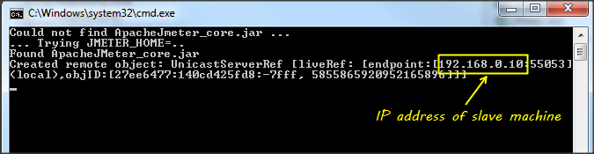

On the **master** systems, go to /bin directory and edit file **jmeter.properites**, add IP slave machine as below

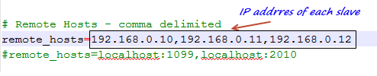

## **Step 2) Run the test**

At this point, you are ready to start load testing. On the master machine, run JMeter GUI and open the test plan.

Click Run on the menu bar; select **Remote start** **->**select **the IP address** of slave machine

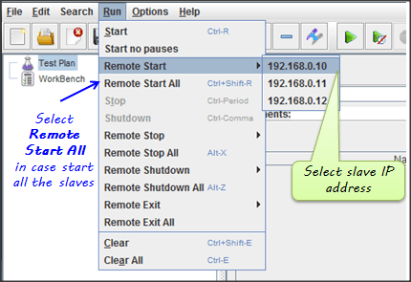

## **Step 3) Troubleshooting**

If you are unable to run test form the above machine and see below error, simply ask an owner of a slave machine to run the JMeter-server.bat File.

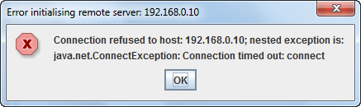

Disable Firewall on both master and slave machines to fix this error.

### **Limitation**

There are some basic **limitations** for distributed testing. Here’s list of the known items:

* Server and all clients must be on **the same** subnet.
* Distributed testing required target server to have the large processing power. The target Server could be easily **overloaded** in case it gets too many requests by distributed JMeter tests.
* A single JMeter can only handle a limited number of threads (100- 300 threads).
* The distributed JMeter tests are complex, difficult for a beginner to build.